Class: COMP 3090 - Database I

Name: DangNhi Ngoc Ngo

Email: DangNhi_Ngo@student.uml.edu

Student ID: 01553277

**HOMEWORK #2**

**Exercise 2.4.1: (a-i)**

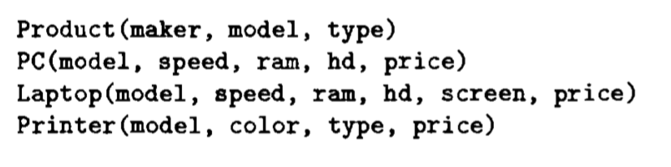

1. **What PC models have a speed of at least 3.00?**

$${R1 :=}_{speed 3.00}\left(PC\right)$$

$${R2 :=}_{model}(R1)$$

Result of the query:

|  |
| --- |
| model |
| 1005 |
| 1006 |
| 1013 |

1. **Which manufacturers make laptops with a hard disk of at least 100GB? $${R1 :=}_{hd 100}\left(Laptop\right)$$**

${R2 :=}_{maker}(Product$ ⋈ R1 $)$

Result of the query:

|  |
| --- |
| maker |
| E |
| A |
| B |
| F |
| G |

1. **Find the model number and price of all products (of any types) made by manufacturer B**

$${R1 :=}_{maker=’B’}\left(Product ⋈ PC\right)$$

$${R2 :=}_{maker=’B’}\left(Product ⋈ Laptop\right)$$

$${R3 :=}_{maker=’B’}\left(Product ⋈ Printer\right)$$

$${R4 :=}_{model, price}(R1)$$

$${R5 :=}_{model,price}(R2)$$

$${R6 :=}_{model,price}(R3)$$

R7 := R4 ∪ R5 ∪ R6

Result of the query:

|  |  |
| --- | --- |
| model | price |
| 1004 | 649 |
| 1005 | 630 |
| 1006 | 1049 |
| 2007 | 1429 |

1. **Find the model numbers of all color laser printers**

$${R1 :=}_{color=true AND type=’laser’}\left(Printer\right)$$

$${ R2 :=}_{model}(R1)$$

Result of the query:

|  |
| --- |
| model |
| 3003 |
| 3007 |

1. **Find those manufacturers that sell Laptops, but not PC’s**

$${R1 :=}_{type=’laptop’}\left(Product\right)$$

$${ R2 :=}_{type=’pc’}\left(Product\right)$$

$${ R3 :=}_{maker}(R1-R2)$$

Result of the query:

|  |
| --- |
| maker |
| F |
| G |

1. **Find those hard-disk sizes that occur in two or more PC’s**

$${ R1 :=}_{S1}(PC)$$

$${ R2 :=}_{S2}(PC)$$

$${ R3 :={}_{hd}(R1 ⋈}_{(S1.hd=S2.hd AND S1.model<>S2.model)}R2)$$

Result of the query:

|  |
| --- |
| hd |
| 250 |
| 80 |
| 160 |

1. **Find those pairs of PC models that have both the same speed and RAM. A pair should be listed only once; e.g., list (i,j) but not (j,i)**

$${ R1 :=}_{PC1}(PC)$$

$${R2 :=}_{PC2}(PC)$$

$${R3 :=R1 ⋈}_{(PC1.speed=PC2.speed AND PC1.ram=PC2.ram AND PC1.model<PC2.model)}R2$$

$$R4 :={}_{PC1.model, PC2.model}(R3)$$

Result of the query:

|  |  |
| --- | --- |
| PC1.model | PC2.model |
| 1004 | 1012 |

1. **Find those manufacturers of at least two different computers (PC’s or laptops) with speeds of at least 2.80**

$${R1 :=}_{speed 2.80}\left(PC\right)$$

$${R2 :=}_{speed 2.80}\left(Laptop\right)$$

R3 := ${}_{model}\left(R1\right){ }_{model}\left(R2\right)$

R4 := ${}_{maker, model}(R3 ⋈Product)$

$${R5 :=}_{R5\left(maker2,model2\right)}\left(R4\right)$$

R6 := ${R4 ⋈}_{(maker=maker2, model<>model2)}R5$

R7 := ${}_{maker}(R6)$

Result of the query:

|  |
| --- |
| maker |
| B |
| E |

1. **Find the manufacturer(s) of the computer (PC or laptop) with the highest available speed.**

R1 := ${}_{model,speed}\left(PC\right){ }_{model,speed}\left(Laptop\right)$

$${R2 :=}_{R2\left(model2,speed2\right)}\left(R1\right)$$

R3 := ${R1 ⋈}_{(speed<speed2)}R2$

R4 := ${}_{model,speed}(R3)$

R5 := R1 – R4

R6 := ${}_{maker}(R5⋈Product )$

Result of the query:

|  |
| --- |
| maker |
| B |